08/2022 - PD
NEW HIRE PACKET

DIRECT SUPPORT WORKER NAME: ___________________________

CONSUMER NAME: ____________________________
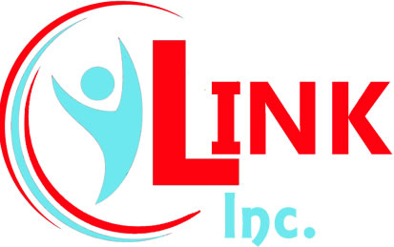
Living Independently in Northwest Kansas
_______________________________________________
2401 E. 13th St. Hays, KS 67601
(785) 625-6942 (V/TT) (785) 625-2334 (FAX)
(785) 625-6137 Payroll Fax

DIRECT SUPPORT WORKER ENROLLMENT FORMS
DO NOT FAX
□ Employment Services Agreement
□ Wage Determination
□ Direct Support Worker Information
□ W-4
□ K-4
I-9 - Employment Eligibility Verification
□ Section 1 – Employee (DSW)
□ Section 2 – Employer (Self Directing Individual)
□ Record Check Request
□ Adult Abuse, Neglect, Exploitation Central Registry
□ Child Abuse and Neglect Central Registry
□ DMV Background Check Consent Form
□ Direct Deposit Form

Please fill out the ENTIRE packet and return to LINK, Inc. either by mail or bringing to the Hays LINK, Inc. office.
Please include a Money Order or Cashier’s Check Payable to LINK, Inc., or Cash in the amount of $25.00 to cover the cost of background checks. NO PERSONAL CHECKS ACCEPTED
*The consumer MUST verify identifications and complete and sign Section 2 of the I-9 Form! Contact LINK, Inc. for complete I-9 Instructions if you have any questions.

Please note Calendars, Handbooks and Forms can be found on our web page at www.linkinc.org

EMPLOYMENT SERVICES AGREEMENT
(Between Consumer/Employer and Direct Support Worker/Employee)

THIS EMPLOYMENT SERVICES AGREEMENT, Made and entered into as of this ___ day of ______________, 20___, by and between ___________________________, (Employer) who is a qualified individual, or his/her representative, who has chosen to self-direct his/her direct care services in accordance with his/her Plan of Care (“POC”) or Individual Service Plan (ISP) pursuant to the Vendor Fiscal/Employer Agent (F/EA) Model adopted and authorized by the State of Kansas, hereinafter referred to as the “SDI” (Self Directing Individual) and ________________________________, (Employee) to provide direct support services to the SDI pursuant to his/her POC or ISP, hereinafter referred to as the “DSW” (Direct Support Worker).
WITNESSETH:

WHEREAS, the SDI is a participant in an HCBS Waiver program administered by the Kansas Department for Aging and Disability Services (“KDADS”) and/or Managed Care Organization (MCO), elected to self-direct his or her attendant care services, and has selected the DSW to be his/her self-directed worker for applicable HCBS Waiver services in strict compliance with the SDI’s POC/ISP and any and all other applicable HCBS program requirements; and

WHEREAS, the DSW acknowledges, understands and agrees that the SDI, or his/her representative, is the employer and has the right to direct, supervise and control the direct care services provided, including but not limited to the nature and extent of services, the schedule and the compensation; and

WHEREAS, the SDI has selected ___LINK, Inc.____ as his/her Financial Management Services Provider (“FMS Provider”) and that the FMS Provider is authorized to do background and registry checks, obtain payroll and related human resource type information from the DSW to process such payroll, process time worked by the DSW, compute, withhold, process and pay applicable taxes and withholdings, and provide other assistance to the SDI pursuant to applicable rules and regulations and in accordance with its FMS Provider Agreement with the SDI; and

WHEREAS, KDADS and/or MCO is not a party to this Employment Services Agreement, however the parties intend that KDADS and/or MCO is a third-party beneficiary and agree that KDADS and/or MCO, at its option, may enforce the terms hereof; and

WHEREAS, the SDI desires to employ the DSW and the DSW desires to accept employment for the purpose of providing designated direct support services for the SDI for such compensation and under the terms and conditions set forth in this Employment Services Agreement; and

WHEREAS, the DSW agrees to strictly comply with the SDI’s Plan of Care (POC)/Integrated Service Plan (ISP) and any and all applicable HCBS Waiver Program requirements any and all Kansas statutes, regulations or policies relating or pertaining to services provided.
NOW, THEREFORE, in consideration of the above and foregoing and the mutual promises and agreements contained in this Employment Services Agreement, it is mutually agreed as follows:

1. EMPLOYMENT AND DUTIES: The SDI hereby employs the DSW, and DSW accepts such employment for the purpose of providing the designated direct support services for the SDI as are set forth on Exhibit “A” which is attached hereto and by reference made a part hereof. The SDI, or his/her representative, shall have the right to determine the specific direct support services to be performed by the DSW and the means and the manner by which those duties shall be performed, and to modify those instructions from time to time during the term of this Employment Services Agreement, provided that such determinations are consistent with his/her POC/ISP and in compliance with applicable HCBS program requirements.

The DSW shall perform his or her duties under this Employment Services Agreement in a good and workmanlike manner and in accordance with rules and instructions provided by the SDI and in accordance with applicable HCBS program requirements. The DSW agrees that he/she will at all times faithfully, industriously and truthfully perform all of the duties required of his/her position. In carrying out these duties and responsibilities, the DSW shall comply with all SDI directives, both written and oral, as are announced by the SDI from time to time. It is also understood and agreed to by the DSW that his/her assignment, duties, responsibilities and reporting arrangements may be changed by the SDI without causing termination of this agreement; provided however, such duties shall be subject to the contents and hourly limitations as contained in the SDI HCBS POC/ISP.

In addition to determining the specific direct support services and the manner and frequency with which they are performed, the SDI has the right to control and determine general rules of conduct during the performance of the support services, such as, but not limited to, no smoking.

This is a personal services contract and none of the direct support services may be assigned or transferred by the DSW without the prior written consent of the SDI, or his/her representative.

2. CONFIDENTIALITY: The DSW acknowledges that, as a condition of his or her employment by the SDI, he or she may obtain access to confidential information of the SDI or protected health information. The DSW shall not in any manner or at any time during his or her employment, or after the date of the termination of his or her employment, either directly or indirectly, divulge, disclose, or communicate to any person, firm, or corporation any personal information related to the SDI. In addition, the DSW agrees to maintain the confidentiality of all SDI information and affairs. Except as required in the performance of the DSW’s services, the DSW will not, during the term of employment or after termination, use or disclose any confidential or proprietary information of SDI, without first obtaining the consent of the SDI. The SDI agrees to maintain the confidentiality of all such information and affairs. To the extent that the DSW may qualify as a “business associate” as defined by the Health Insurance Portability and Accountability Act of 1996 (“HIPAA”), and privacy regulations published by the U.S. Department of Health and Human Services contained at 45 CFR §§ 160 and 164 (“HIPAA Regulations”), which may be periodically revised or amended, and other applicable laws, the DSW agrees to protect and provide for the privacy and security of Protected Health Information (“PHI”), as defined by HIPAA that comes into the DSW’s possession.

3. TERM: Both parties acknowledge and agree that this employment relationship is one of employment-at-will and may be terminated by either party at any time with or without cause.

4. COMPENSATION: The compensation to be paid to the DSW for the direct support services is set forth on Exhibit “A” which is attached hereto. Compensation for various services may vary. The SDI negotiates the rate of pay with the PCSW. The DSW is responsible for calling the Kansas Authenticare toll free number (800-903-4676) from the SDI’s phone they have registered with FMS Provider. The DSW will call the number at the beginning of their time worked to clock in. At the end of the time worked the DSW will call the number to clock out and enter the activity codes for each task they did during the time worked. If a clock-in or a clock-out time is missed the SDI should immediately contact FMS Provider and report the time and the activity codes, if applicable, until such time the Authenticare system is made available to the SDI for verification of their DSW’s time worked. Payments will be subject to applicable payroll taxes and withholdings. This includes the SDI’s request for Workers Compensation coverage on all of their employees regardless of relationship. The FMS Provider will issue payment on behalf of the SDI to the DSW on a twice monthly basis during the term of this Employment Services Agreement. DSW shall strictly comply with all rules, regulations and/or policies (State or Federal), including those maintained by the AuthentiCare System, regarding logging of units/hours of services provided on a daily basis in order to receive payment for services rendered. Failure to provide accurate and truthful data regarding services rendered may result in termination and referral to State and/or Federal authorities for Medicaid Fraud, criminal prosecution or the like.

The DSW will not seek, request or encourage the SDI to provide him or her with additional compensation or benefits in addition to the compensation described above. The DSW/employee understands they are expected to work within the parameters of the POC/ISP and compensation for hours worked above this are the responsibility of the SDI/Employer to pay out of pocket.

__________ (DSW initials) I understand if I am directed by the SDI to work above the approved ISP/POC I will receive payment for hours above the approved POC/ISP on the payroll following the FMS agent’s receipt of payment from the SDI/Employer.

__________ (DSW Initials) DSW’s may NOT work over 40 total hours per week per consumer. (Sunday through Saturday)

__________ (DSW initials) I understand if I fail to clock in and out on time any hours above the approved POC/ISP will be billed to the SDI (unless SDI corrects the time in the AuthentiCare System). I understand I will be paid for these hours on the next payroll after the FMS agent receives receipt of payment from the SDI/Employer.

5. FRINGE BENEFITS: There are no fringe benefits provided by the SDI.

6. TERMINATION: This Employment Services Agreement may be terminated by either party at any time, with or without cause.

7. GOVERNING LAW: It is agreed that this Employment Services Agreement shall be governed by, construed, and enforced in accordance with the laws of the state of Kansas and applicable governmental statutes, rules, and regulations, Medicaid Provider requirements, and other applicable policies and procedures.

8. MODIFICATION OF AGREEMENT: Any modification of this Employment Services Agreement shall be binding only if evidenced in writing signed by each party or an authorized representative of each party. The Parties shall not assign, subcontract, or delegate any duties or obligations required by this Agreement to any other individual, agency, or organization. This Agreement supersedes all prior negotiations and agreements between the parties relative to the transaction and services contemplated by this Agreement (written or oral), which contains the entire understanding of the parties. The terms and provisions of this Agreement shall be construed in accordance with and governed by the laws of the State of Kansas. In the event Judicial Intervention is necessary, the Parties agree that venue shall solely be in the District Court for Shawnee County, Kansas.

9. BINDING EFFECT: This Employment Services Agreement shall bind and inure to the benefit of the respective heirs, personal representatives, successors, and assigns of the parties.

10. BACKGROUND CHECK:

_________ (DSW Initials) Per HCBS Waiver regulations Parties acknowledge that DSW’s employment is subject to his/her passing all background checks at least every two (2) years. During DSW’s employment, you will notify your employer and LINK, Inc. if you are convicted/adjudicated of an offense which prohibits employment in an adult or child care home, home health agency, or as an HCBS Provider, service providing employee, contractor or subcontractor in the State of Kansas, pursuant to K.S.A. 39-970, K.S.A. 85-5117 and K.S.A. 39-2009, respectively. Such conviction/adjudication will result in immediate dismissal per the above sited statutes. DSW shall cooperate in providing requisite information regarding the same.

__________ (DSW Initials) I understand that I am responsible for paying in advance, $25.00 by Cash (exact change only), Money Order or Cashier’s Check only for ALL initial and subsequent Background checks, as required by the State of Kansas and that I am required to report ANY felonies/misdemeanors after the initial background check is conducted, but before the next 2 year check. (No personal checks accepted)

__________ (DSW Initials) In the event of employment, I understand that false or misleading information given in my application or interview(s) may result in discharge. I understand also, that I am required to abide by all rules and regulations of the employer.
I understand that if hired, my employment is at will and may be severed by either party at any time with or without cause. I agree to submit to all required backgrounds check if hired. I understand that neither this document, nor an offer of employment, constitute an employment contract unless a specific document to that affect is executed by the employer and employee in writing.

__________ (DSW Initials) Unemployment Compensation
Upon Separation of employment from a consumer, whether temporary or permanent, I agree to immediately notify LINK FMS Department and request additional work. I acknowledge that failure to do so may disqualify me from unemployment benefits

“SELF DIRECTING INDIVIDUAL” (SDI)/Employer

________________________________________________ Date: ______________
Signature, individually or by representative

“DIRECT SUPPORT WORKER” (DSW)/Employee
____________________________________________________ Date: _______________
Printed Name

____________________________________________________
Signature


Living Independently in Northwest Kansas
________________________________________________

2401 E. 13th Hays, KS 67601
(785) 625-6942 (V/TT) (785) 625-6137 (FAX)

WAGE DETERMINATION FORM

Consumer Name: _______________________________

Direct Support Worker: ____________________________________

Effective Date: ___________________________

As the employer, you have the right to choose the wage your Direct Support Worker starts at, as long as it is within the following guidelines:

- The maximum amount your worker can receive is $12.08/hr.
- The minimum amount your worker can receive is $7.25/hr.

I (consumer name) _________________________________, wish to start my Direct Support
Worker ___________________________________________, at a rate of $________________
Per hour.
- If you wish to change the rate of pay for your DSW, you must
request a new Wage Determination Form.

___________________________________ ______________
Employer Signature Date

___________________________________ ______________
DSW Signature Date

PD Waiver

***IT IS REQUIRED THAT YOU PROVIDE AN EMAIL ADDRESS***
DIRECT SUPPORT WORKER
INFORMATION

Name ___________________________ ________________ ___________________________
First Middle Last

Social Security Number______/____/______

Address _____________________________________________________________________
NUMBER & STREET CITY STATE ZIP CODE

Mailing Address if different than physical Address (PO Box, etc.)________________________

Telephone Numbers: Home ( ) - Cell ( ) - .

Male __________ Female __________ County of Residence _________________

**E-mail Address: _____________________________ Birthdate _______________________

**All DSW’s must be at least 18 years of age**

****************************************************************************
Please circle correct answer:

Bilingual – Yes or No Sign Language - Yes or No

Is Worker related to Consumer – Yes or No If Yes, What Relationship ________________________

Language Accommodation Required – Yes or No

*******************************************************************************************
Check the following:

Referral Source: Friend State Employment Office

Advertisement. If so, where? _______________________________

Other (Specify) __________________________________________

Are you interested in working for another client? Yes No

I certify the answers given herein are true and complete to the best of my knowledge. I authorize investigations of all statements contained in this application for employment as may be necessary in arriving at an employment decision.
This application for employment shall be considered active for a period of time not to exceed six (6) months.
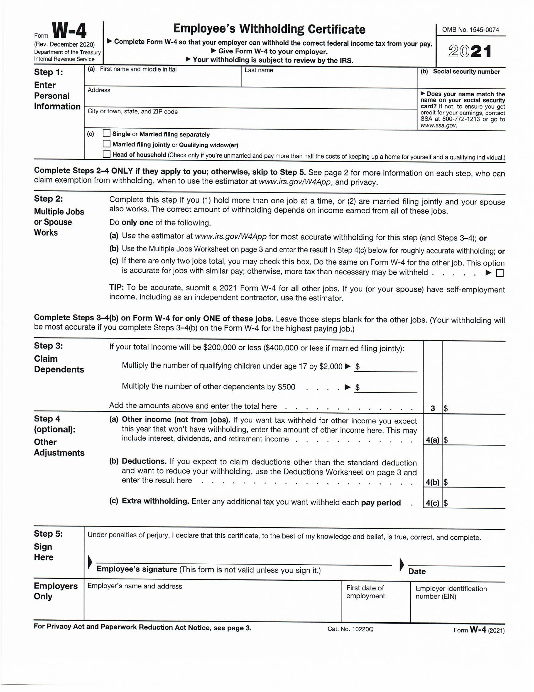
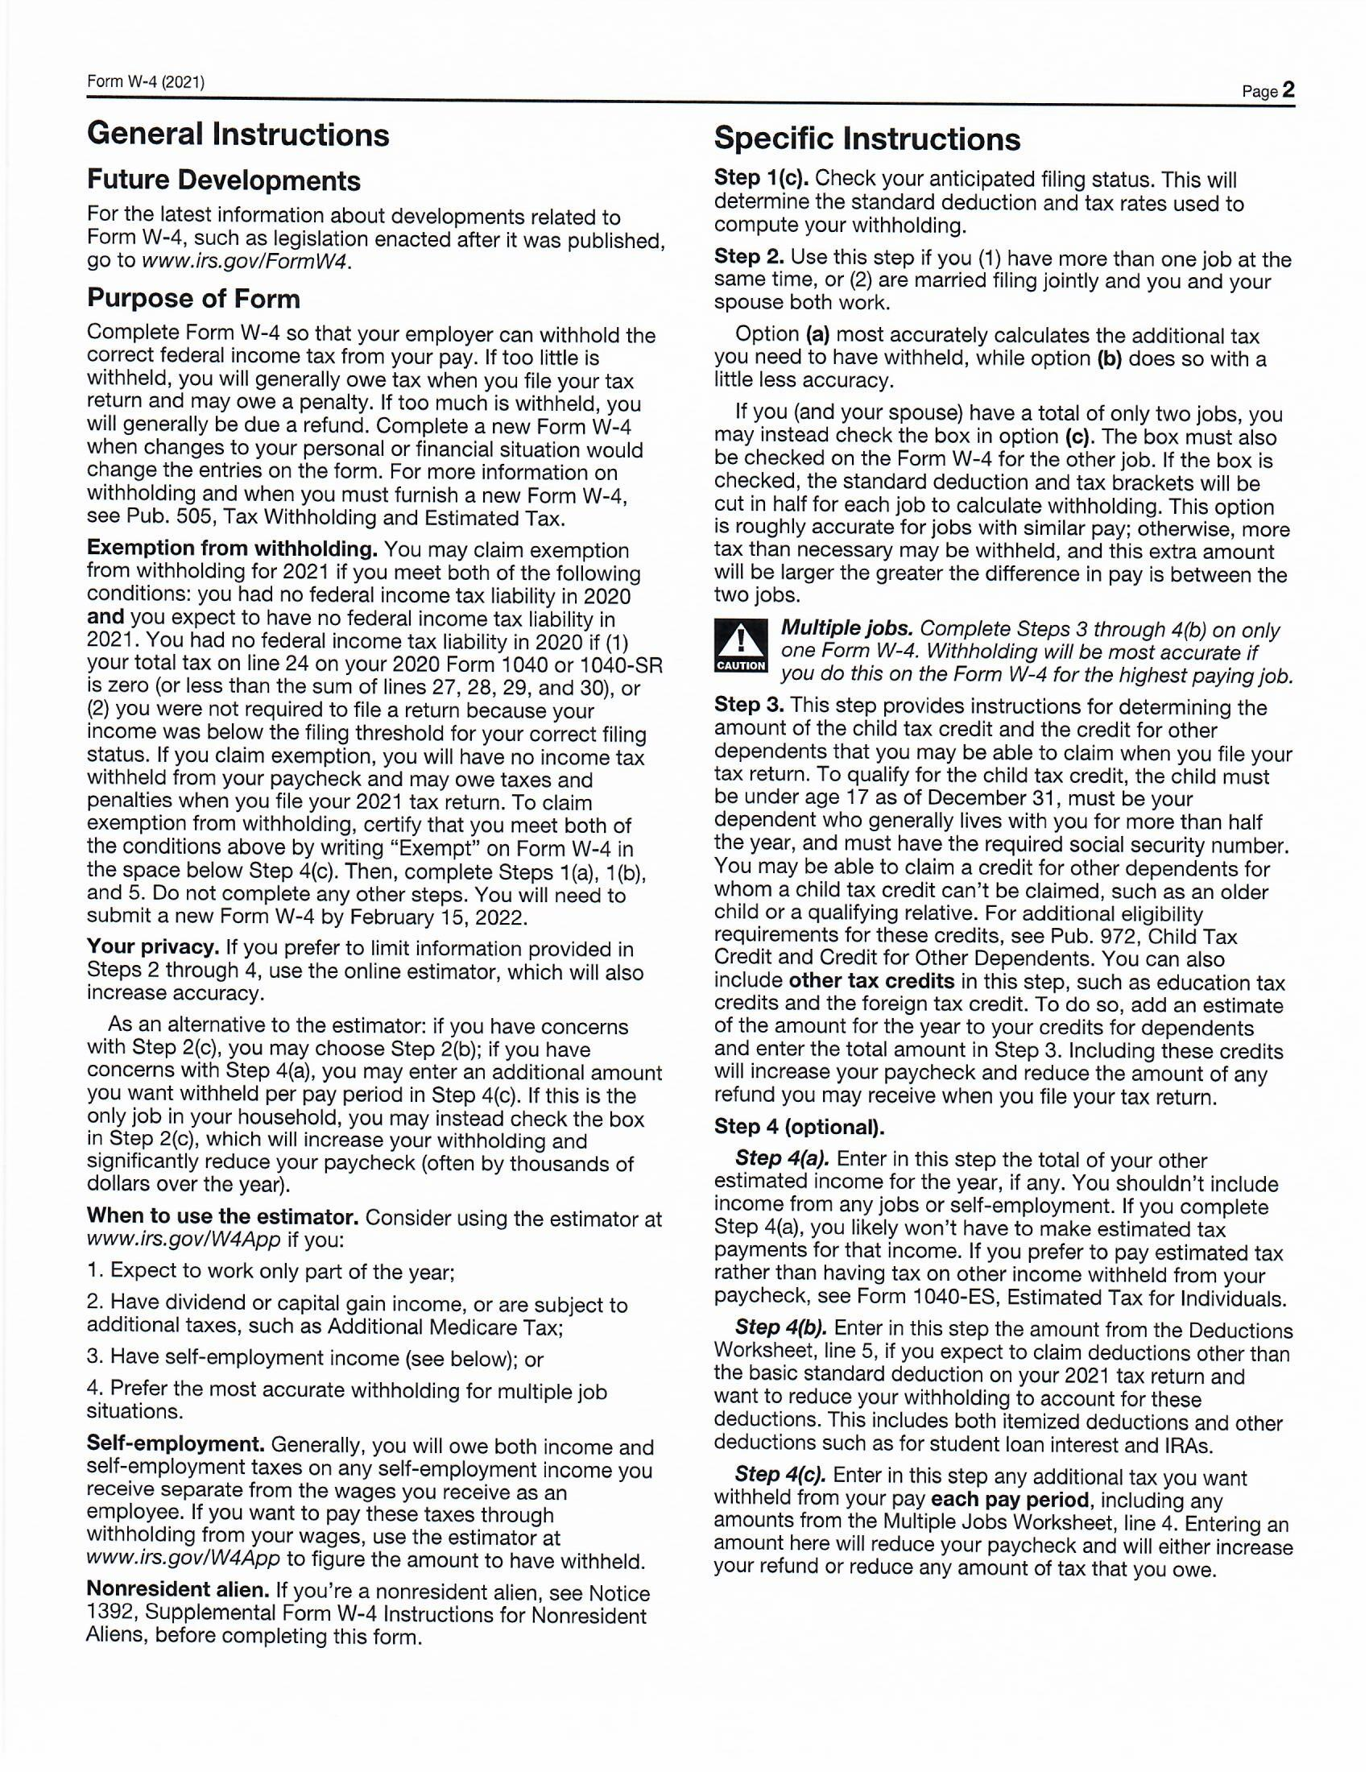
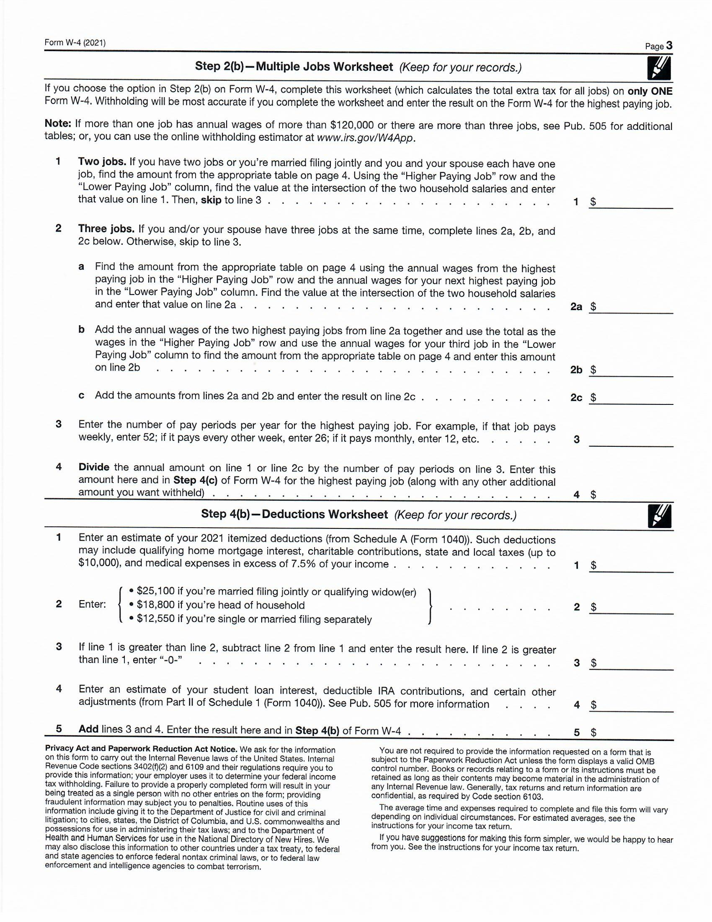
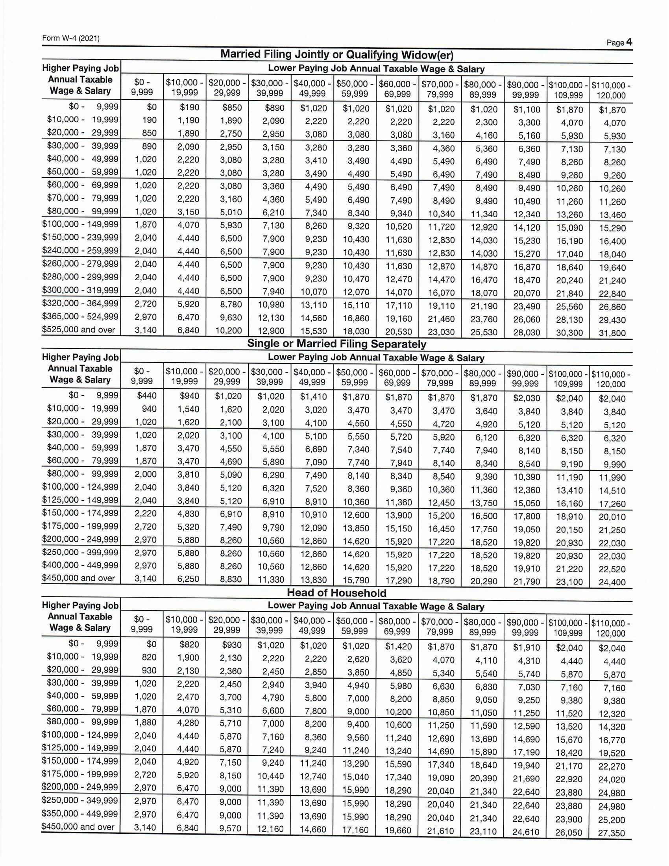
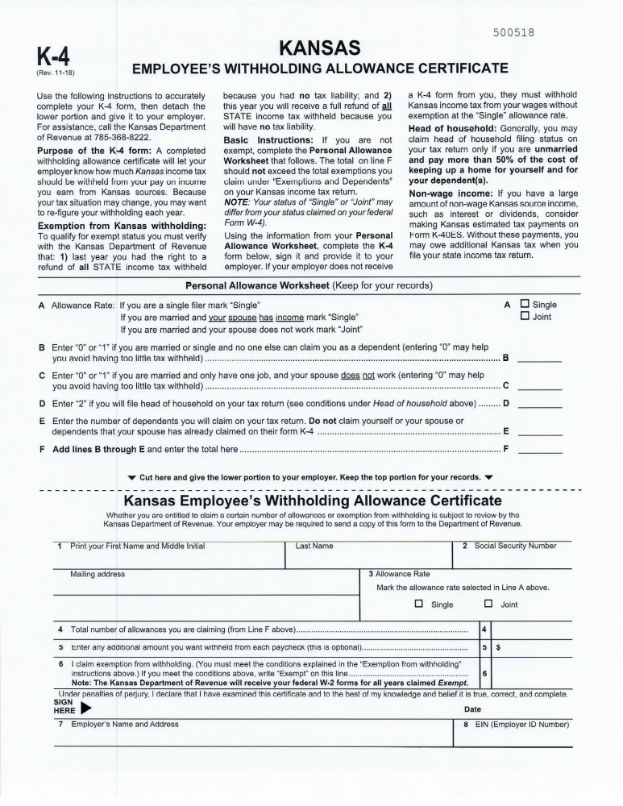
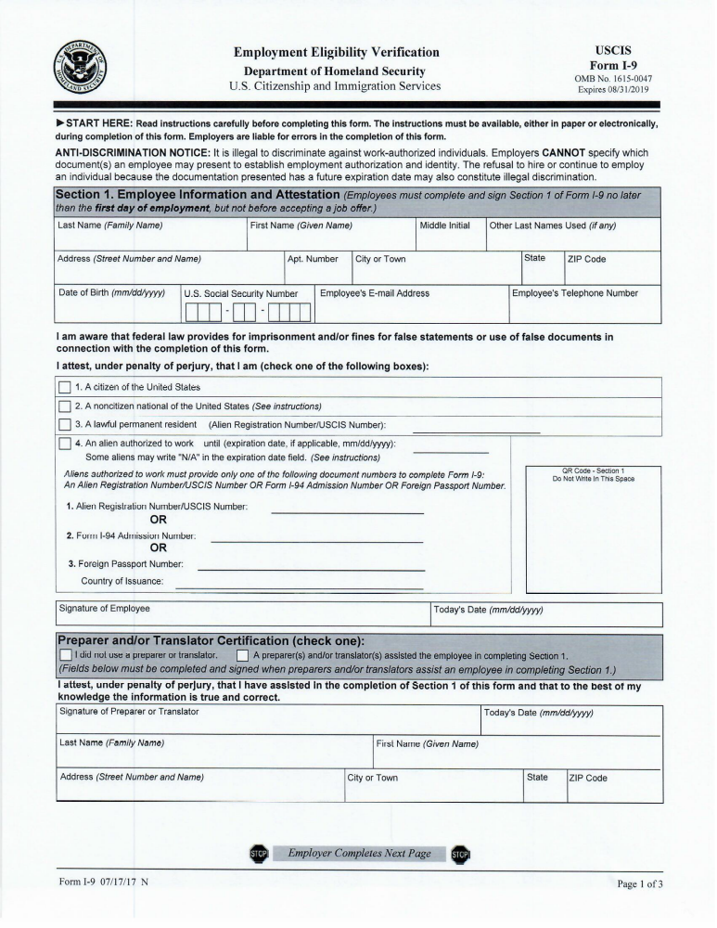
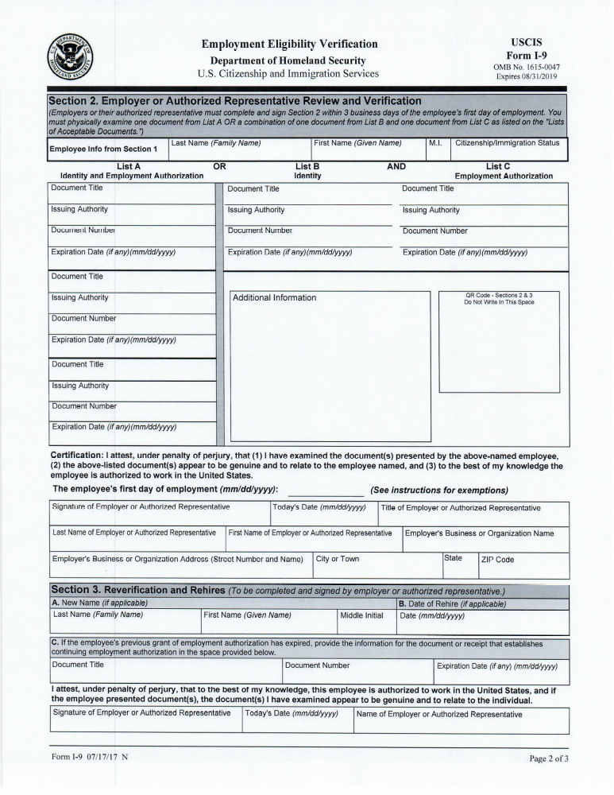
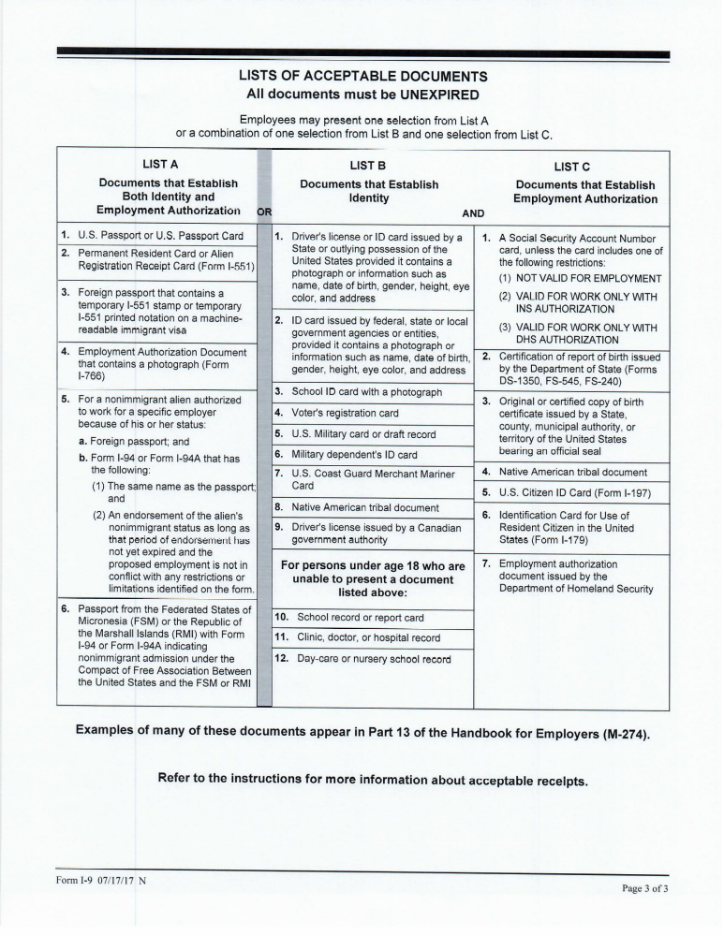

RECORD CHECK REQUEST
(NON-CRIMINAL JUSTICE AGENCY SUBMISSION)
Cash (exact change only), Money Order or Cashier’s Check for $25.00 MUST accompany this form
ATTENTION: It is required that you complete this form and return to LINK. If you have questions, you may call the LINK FMS I & A at 1-800-569-5926.

TO: WHOM IT MAY CONCERN
A criminal history/APS/Child Abuse and Neglect Central Registry/Nursing Registry records check of the Kansas central records repository is requested for the following individual. (Print or Type the following information).
A finger print card is not included.

Full Name: ______________________________________________________________________________
Last First Middle
Alias/Maiden Name: ______________________________________________________________________
Last First Middle
Other Alias Name: ________________________________________________________________________
Last First Middle
Other Alias Name: ________________________________________________________________________
Last First Middle
Current Address: _________________________________________________________________________

Date of Birth: _________________________ Social Security No. _____ - ____ - _____
(MM/DD/YY)
Sex: _____ Race: _____________________ Place of Birth: ____________________________
(City, State or Foreign Country)

EMAIL Address: __________________________________ Telephone Number: ___________________________

I, _______________________________, give permission for the release of any information concerning myself in all
(Print Name of DSW or Employee)
Central Registries to LINK, Inc., Atten: FMS I & A, 2401 E. 13th, Hays, KS 67601, (785) 625-6942. I understand that all information released will be for the exclusive and confidential use of the above named organization/person/agency.

____________________________________________
(Signature) (Date)

FOR OFFICE USE ONLY

Received in Admin Asst _____________ (Date)_______(By) Submitted to Program Asst. ____________(Date)________ (By)

KBI Submitted on _____________________(Date) KBI Check Received____________________ (Date)

APS Request Emailed _________________ (Date) APS Results Received ___________________ (Date)

CAR Request Emailed _________________ (Date) CAR Results Received ___________________(Date)

DMV Submitted ______________________(Date) DMV Results Received ___________________(Date)

OIG Submitted/Received ________________(Date) KNAR Submitted/Received ________________(Date)

I-9 Completed _________________________(Date) Consumer Name _____________________________
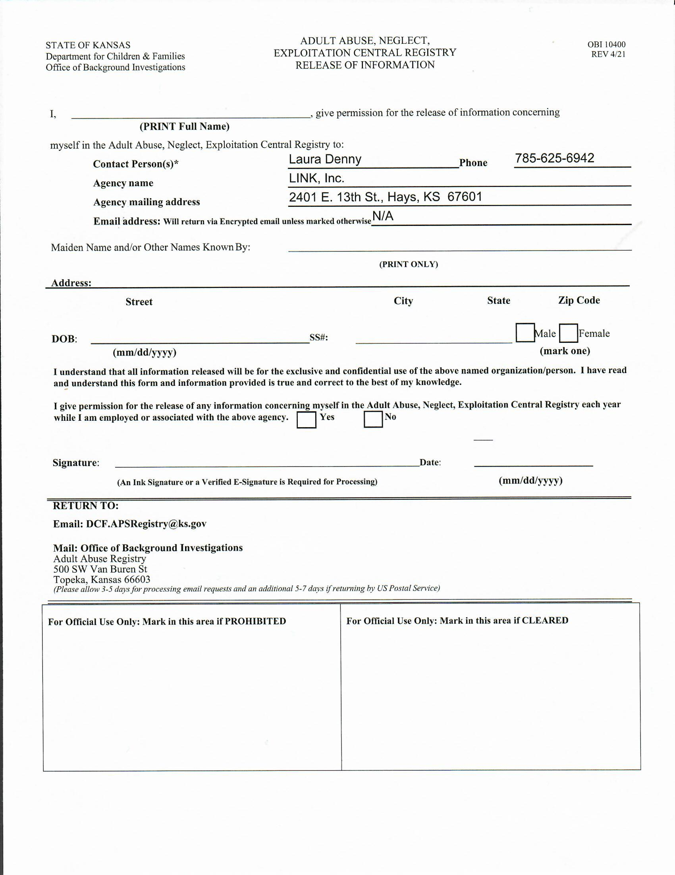
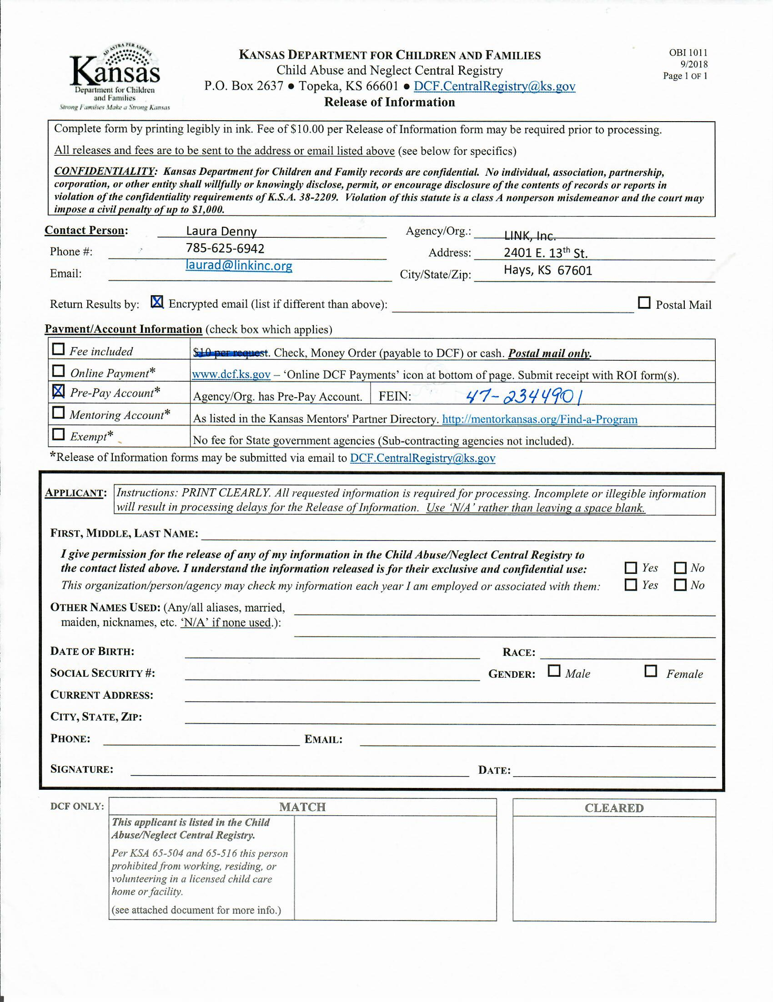
DMV Background Check
Kansas 3rd Party Consent Form

*PLEASE PUT THE INFORMATION EXACTLY AS IT IS ON YOUR LICENSE*

I hereby certify that my name is ______________________________________________________________
(First Name) (Middle Initial) (Last Name)

Address _________________________________________________________________________________
(Street Address) (City) (State) (Zip)

Birthdate _____________ Telephone Number _________________________
(MM/DD/YYYY)

Driver’s License Number _____________________________________ Don’t have one □

State Id Number _____________________________________

Issuing Authority (State) _____________________________________

I hereby authorize LINK Fiscal Agent to obtain my vehicle registration and/or driver’s license record information including my personal information on those records.

________________________________________________________ _____ ________________________
Signature (Date)

DIRECT DEPOSIT FORM
(Direct Deposit is Required)

DSW Name:_________________________________________ !!! PLEASE PRINT CLEARLY!!!

- If you have a bank account, fill out the bank information below:
Bank Name: ____________________________________________________
Routing #: _____________________
Checking Acct #: __________________________ Savings Acct #: _________________
(Attach voided blank check)
- If you do not have a bank account:

□ Commerce Direct Check Card (complete form below) $4.95 setup fee will be deducted
from first direct deposit.
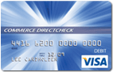
Employee Information

Name

___________________________________________________________\____\______
Social Security #Home Phone ___Cell Phone___Date of Birth

Mailing Address

City, State, Zip

Authorization for Electronic Entries to Commerce Direct Check Card

The undersigned hereby authorizes LINK, Inc. (the Employer) to make electronic credit entries and any necessary adjustments involving these entries in the account identified below at Commerce Bank (the Bank) and authorizes the Bank to accept such entries and make any necessary adjustments. It is agreed that these entries will be made under the rules of the National Automated Clearing House Associations. This authorization will remain in effect until written notice of termination is delivered to the Employer in a timely manner so as to afford the Employer an opportunity to act thereon, In no event shall such termination be effective as to entries processed prior of such notice.

Signature: ________________________________________________ Date: ______________

Signature: _____________________________________ Date: ____________________

